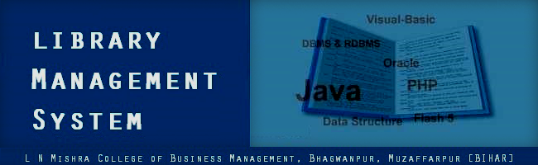

Group Name : Adesh Anand
Md. Shadmaan
Md. Mobashshir Adil Vikrant Kumar Ranjan

Department : Bachelor of Computer Applications

College : L N Mishra College of Business
Management, Muzaffarpur

Project Topic : Online Library Management
System



ACKNOWLEDGEMENT

This whole project was a mixed experience. The task was not easy at all, as we had initially thought. While working on this project we realized that practically developing a system is not as simple as of laying its theoretical basics. It takes patience, dedication and direction of united team to accomplish the task. The task was even harder due to the ill-experienced new team.
Only one person was aware of this project. He is none other than our Project Head – Er. Arindam Saha. Whatever we mention about his contribution is insufficient. AVS2 heartily acknowledge his guidance.
We would also like to thank Vivek Kumar for his valuable suggestions.



CONTENTS

System Requirement Specification 4

Requirement Analysis of the Project 5

Entity-Relationship Diagram 6

Data Dictionary 9

Context-Flow Diagram 11

Data-Flow Diagram 12

Site-Map 19

Screen Shots 20

Project Team and Remarks 38
SYSTEM REQUIREMENT SPECIFICATION

Objective:
This project is aimed at developing an online library management system that is of importance to a college. The online library management system is a local software system. This system can be used to manage all aspects of a library.

User Requirements:
- There are mainly three types of users-
- Administrator[ADMIN]
- Head Librarian
- Staff Librarian
- Every user needs “USER ID” and “PASSWORD” to log in. Without log in no one can use the system.
- “USER ID” and “PASSWORD” of every user is created when they are added to the system.
- Every member of ADMIN-Group has its own “USER ID” and “PASSWORD” and everyone can change his “PASSWORD”. “USER ID” and “PASSWORD” is given to each member of ADMIN_Group after the installation of the system. ADMIN can manage all the administrative aspects of the library. Administrative aspects of this online library management system include-
- Employee Management
  - Adding LIBRARIAN
  - Deleting LIBRARIAN
  - Modifying Librarian
  - Resetting password of LIBRARIAN
  - Viewing all LIBRARIAN records
- Student Management
  - Adding student
  - Deleting student
  - Modifying Student
  - Resetting password of student
  - Viewing all student records
- ADMIN can change his password.
    - The number of members in Staff-LIBRARIAN_Group can vary. LIBRARIAN can issue and/or return book(s) by/from student(s). Every member of Staff-LIBRARIAN_Group can change his “PASSWORD” as well as they can offer student(s) to change their “PASSWORD(S)”. LIBRARIAN can view library record of all the students.
    - Head librarian is in charge of managing BOOK-Stock of the library. His book related tasks include:-
- Adding Book
- Deleting Book
- Modifying Book
- Searching Books
- Viewing all Book records
    - Head Librarian can change his password.
    - All students have “USER ID” and “PASSWORD”. But, student(s) can not log in into the system. The “USER ID” is allocated to the students for their unique identification and their “PASSWORD” is used for their verification during issuing and returning of book(s).
    - In case any of LIBRARIAN or student forget his password; he can contact to ADMIN with own College_ID and a self-signed application. After this ADMIN must reset his “PASSWORD”.
    - “PASSWORD” can never be blank. Any user be it ADMIN, LIBRARIAN and student can never set his password value to null.
    - The “USER ID” against which ADMIN resets “PASSWORD” and the “Date” when the “PASSWORD” has reset; can be stored for future reference**.

* To add and/or delete “USER ID(s)” and/or reset “PASSWORD(s)” in ADMIN_Group, contact to the system manufacturers.
** User(s) can not access these records. For accessing these records contact to system manufacturers.

Date: Date:

Place: Place:

Customer’s signature: Manufacturer’s signature:
REQUIREMENT ANALYSIS OF THE PROJECT

Software Requirements:
- Web Technology: Java EE 1.6
- Database: MS-Access - 2007
- Server: Apache 7.0.22
- Development Tool: Eclipse Juno
- Web Browser: Google Chrome 26.0.1410.43 [preferred]
- Languages Used: Java
- Operating System: Windows 7 Home Basic

Hardware Requirements:
  - Processor: Intel Pentium IV
  - RAM: 2GB
  - Hard Disk: 32GB
  - Monitor: Any gray-scale/color monitor

Future Scope:
- Administrator can control the maximum number of books to be issued.
- Online Portal for Students is possible facilitating advance booking for study-materials.
- Automatic password generation and delivery of the same to corresponding user via e-mail can be implemented.
- The project will help librarians to manage their work faster.
- It enables them to maintain huge records of library.
- It will enable them to keep records for every entity of library.
- It is easy to maintain in future prospects.

ENTITY-RELATIONSHIP DIAGRAM

Employee[Administrator, HEAD OF LIBRARY, STAFF]

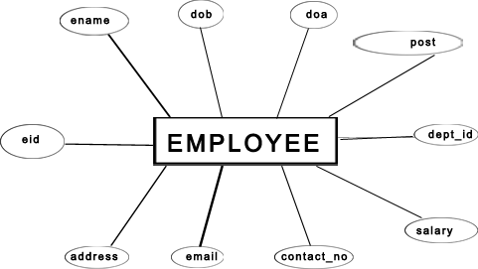

Student

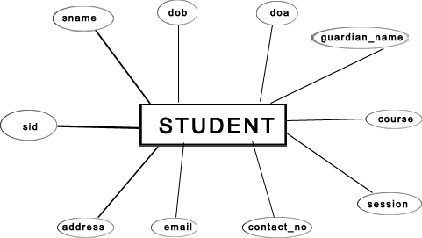

ENTITY-RELATIONSHIP DIAGRAM

Book

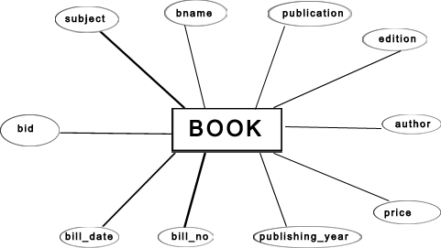

ENTITY-RELATIONSHIP DIAGRAM

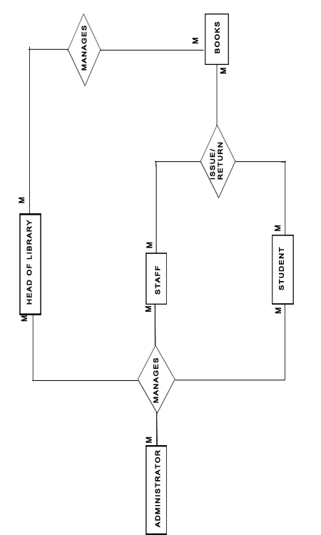
*MANAGES = [ADD,DELETE, MODIFY, SEARCH, SHOW ALL]

DATA DICTIONARY

1. tbl_user

NAME | TYPE | SIZE | CONSTRAINT
uid | text | 255 | Primary key
password | text | 255 | Not null

2. tbl_employee

NAME | TYPE | SIZE | CONSTRAINT
eid | Text | 255 | Primary key
ename | Text | 255 | Not null
dob | Date/Time |  | Not null
doj | Date/Time |  | Not null
post | Text | 255 | Not null
dept_id | Text | 255 | Not null
salary | Number | Long Integer | Not null
contact_no | Text | 255
email | Text | 255
address | Text | 255 | Not null

3. tbl_student

NAME | TYPE | SIZE | CONSTRAINT
sid | text | 255 | Primary key
sname | text | 255 | Not null
dob | Date/Time |  | Not null
doa | Date/Time |  | Not null
guardian_name | text | 255 | Not null
course | text | 255 | Not null
session | text | 255 | Not null
contact | text | 255
email | text | 255
address | text | 255 | Not null

4. tbl_book

NAME | TYPE | SIZE | CONSTRAINT
bid | text | 255 | Primary key
subject | text | 255 | Not null
bname | text | 255 | Not null
publication | text | 255 | Not null
edition | text | 255 | Not null
author | text | 255 | Not null
price | Number | Long Integer | Not null
publishing_year | text | 4 | Not null
vendor_name | text | 255
vendor_place | text | 255
bill_no | text | 255
bill_date | date/time |  | Not null

5. tbl_libraryIssueReturnBookRecord

NAME | TYPE | SIZE
sid | Text | 255
bid | Text | 255
issued_by | Text | 255
issue_date | Date/Time
return_date | Date/Time

6. tbl_adminPasswordResetLog

NAME | TYPE | SIZE
uid | text | 255
date_time | Date/Time

CONTEXT-FLOW DIAGRAM

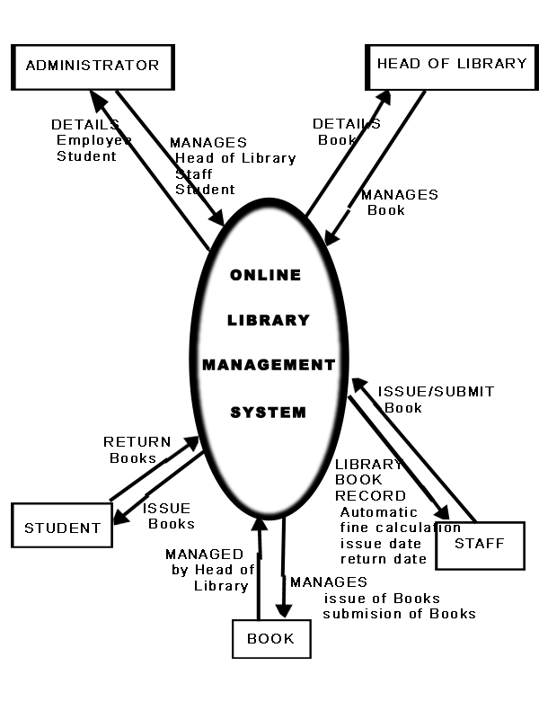

DATA-FLOW DIAGRAM

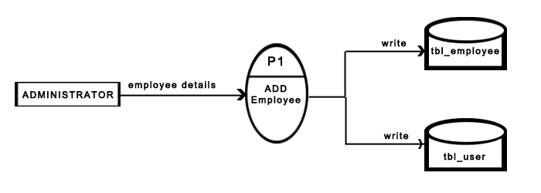

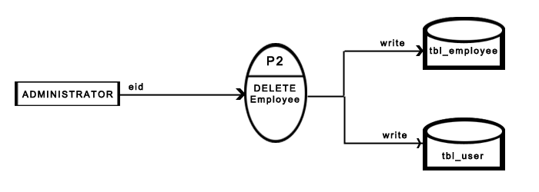

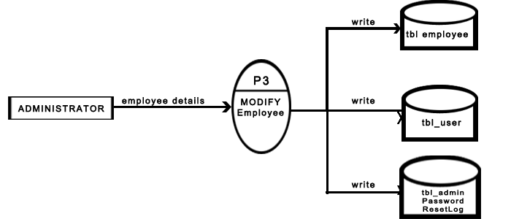

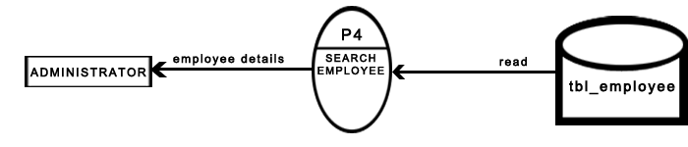

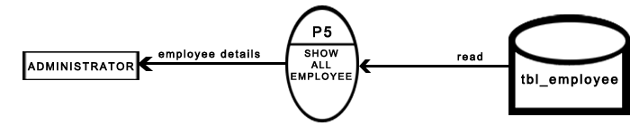

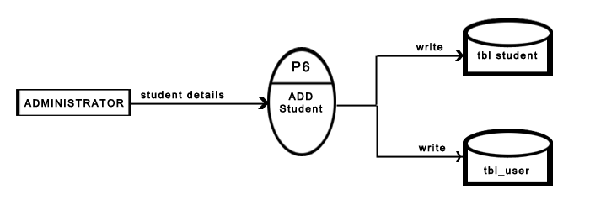

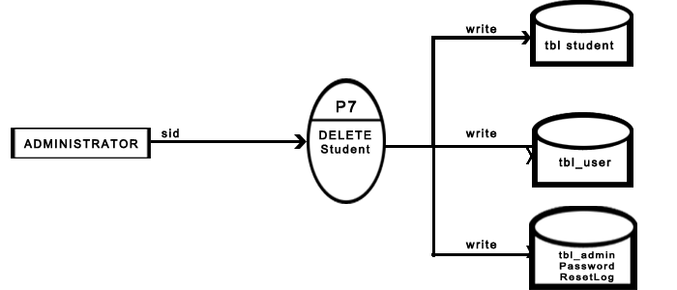

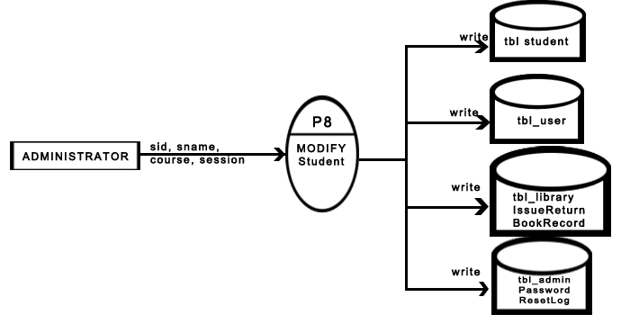

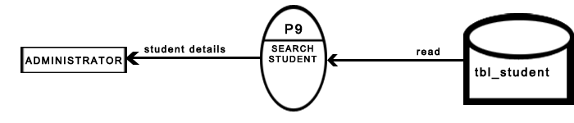
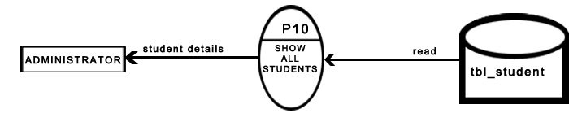

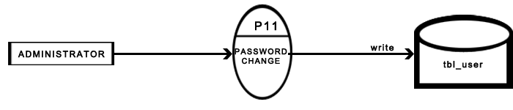

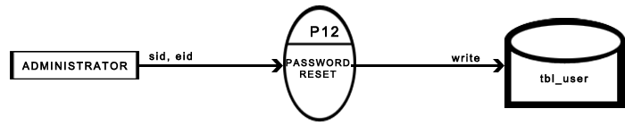




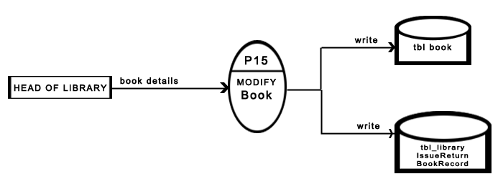




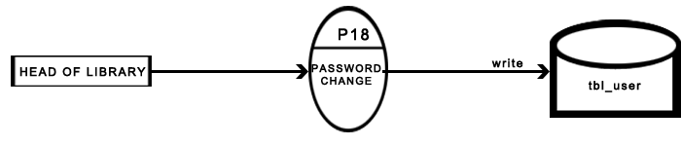

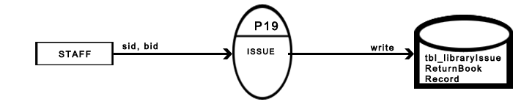

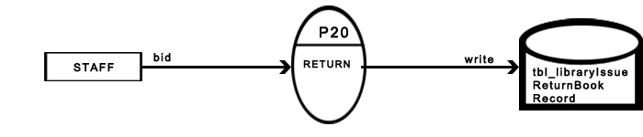

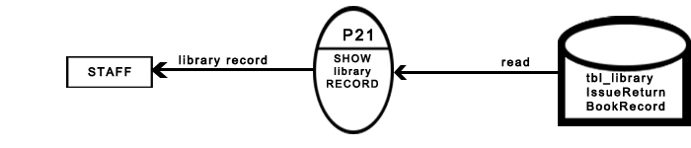

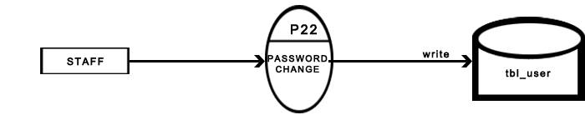

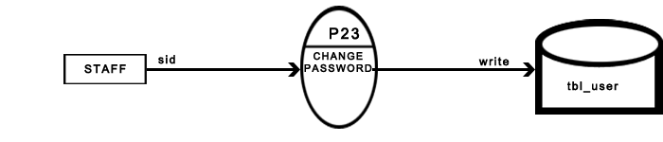

SITE-MAP
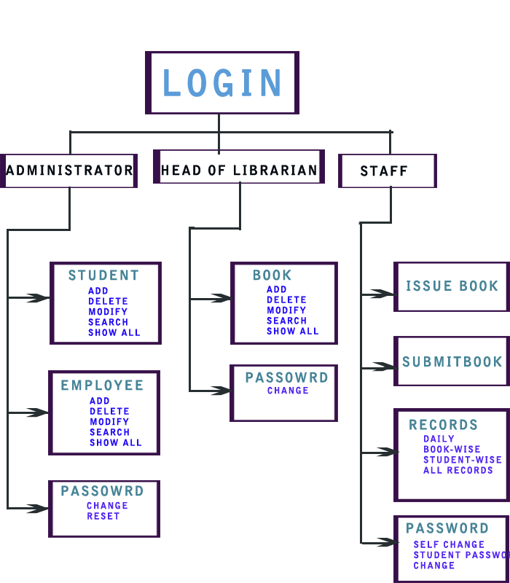
SCREEN-SHOTS
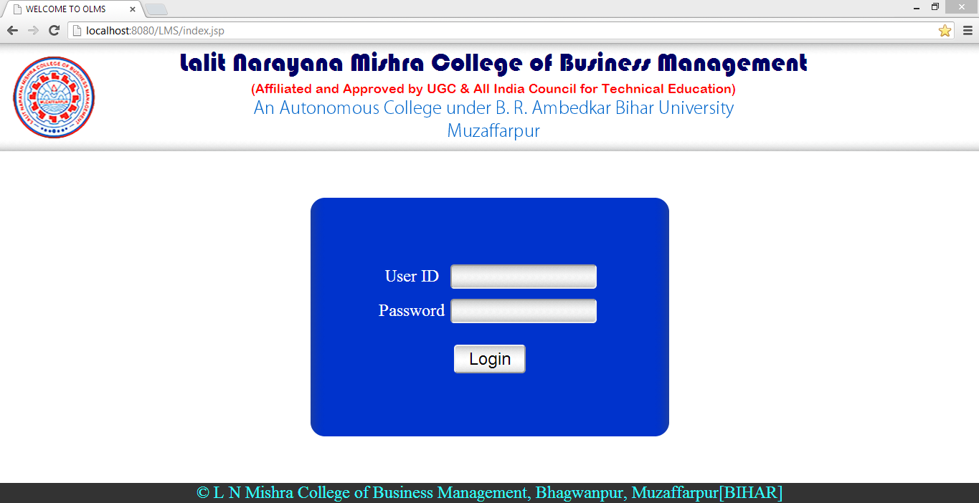
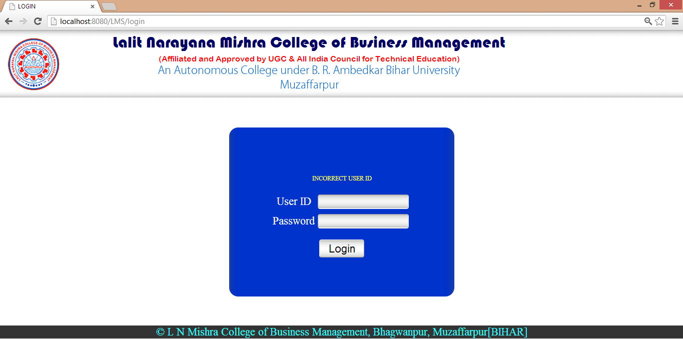
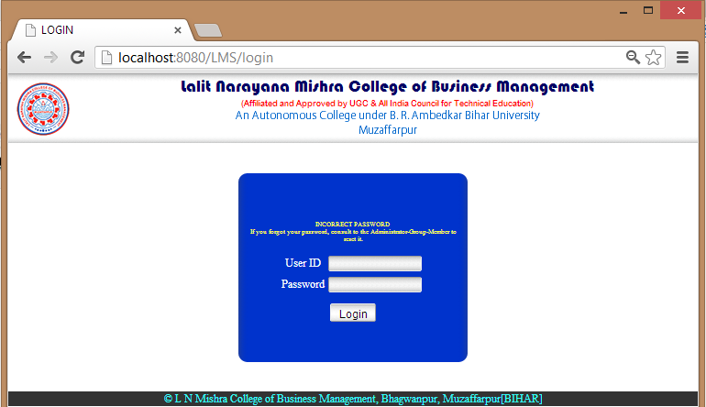
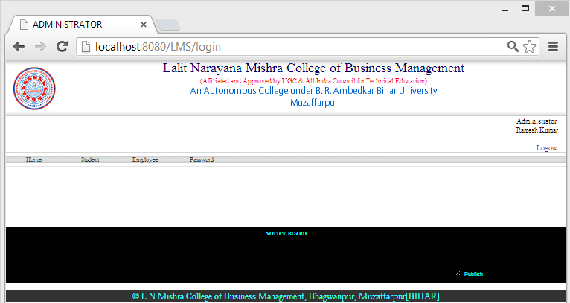
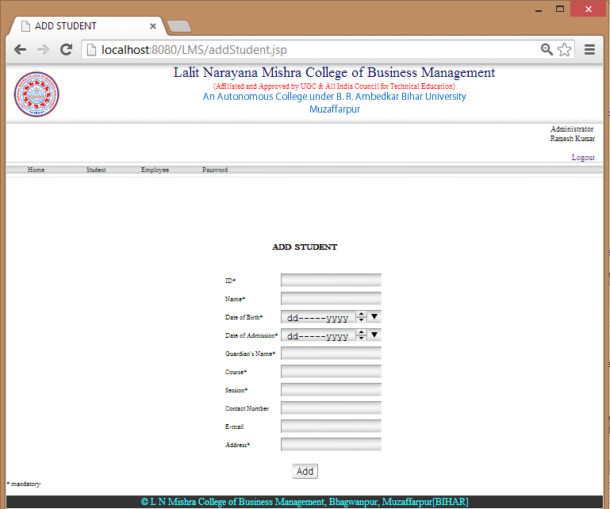
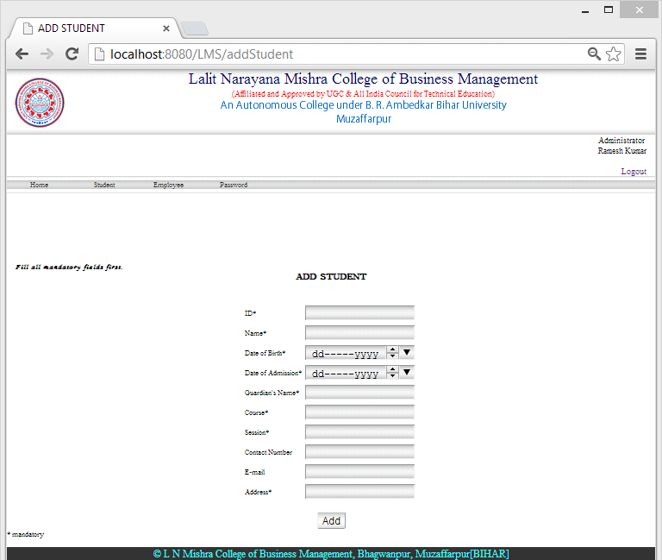
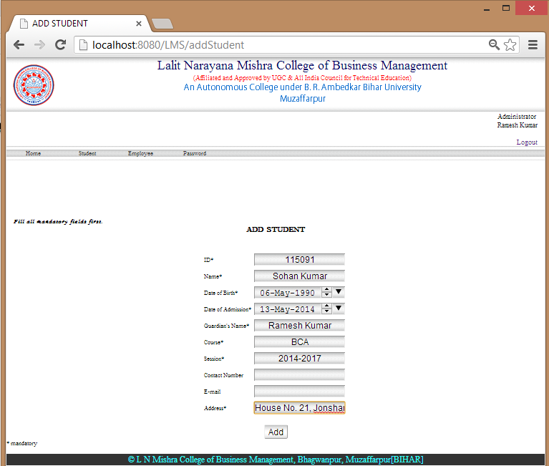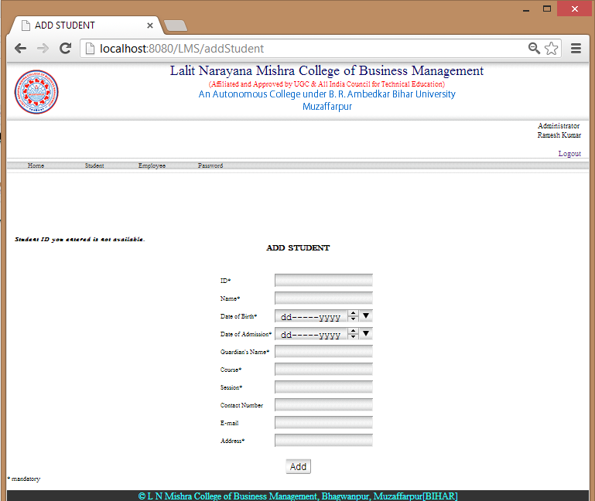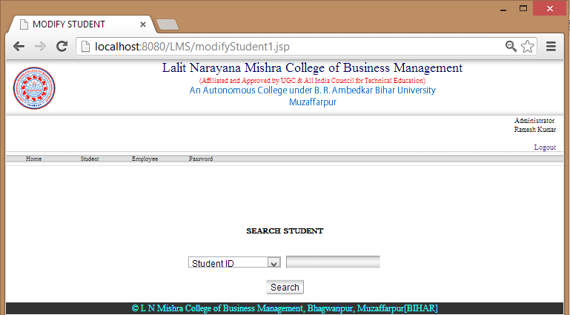

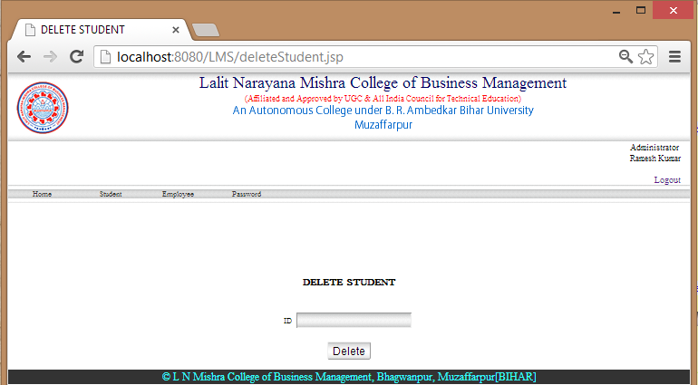
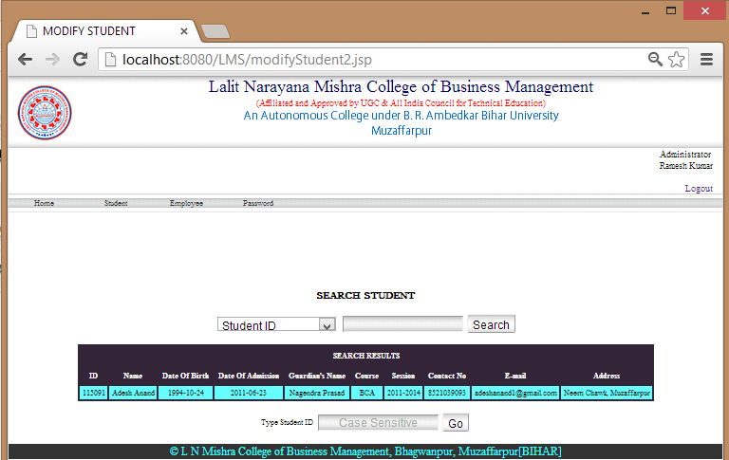

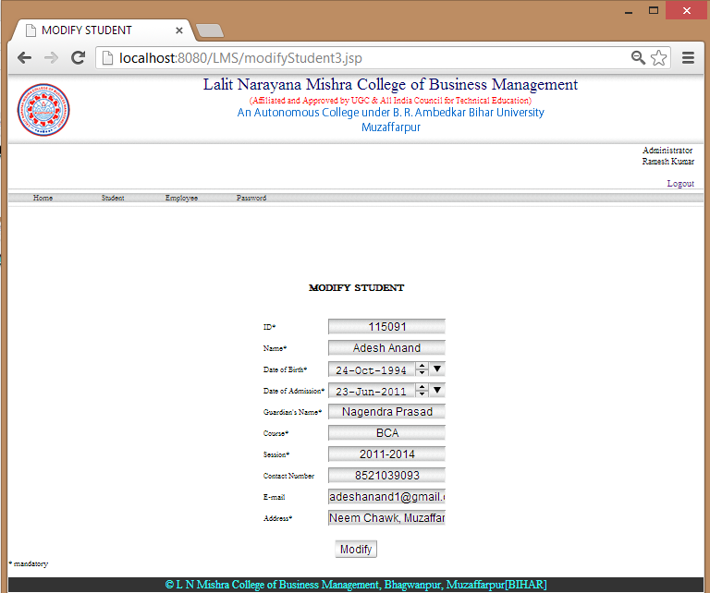
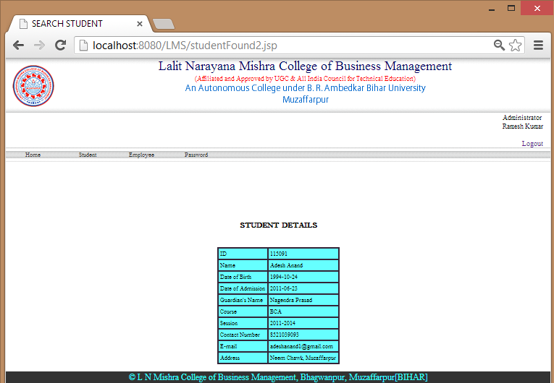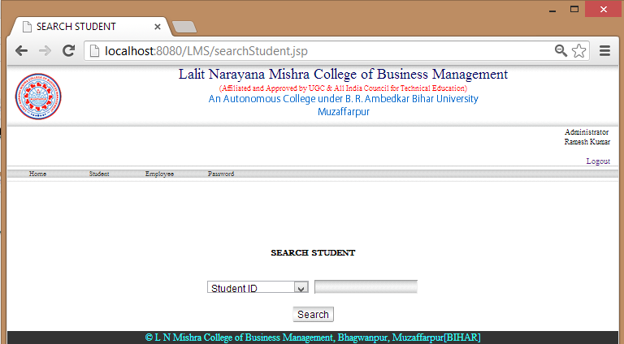
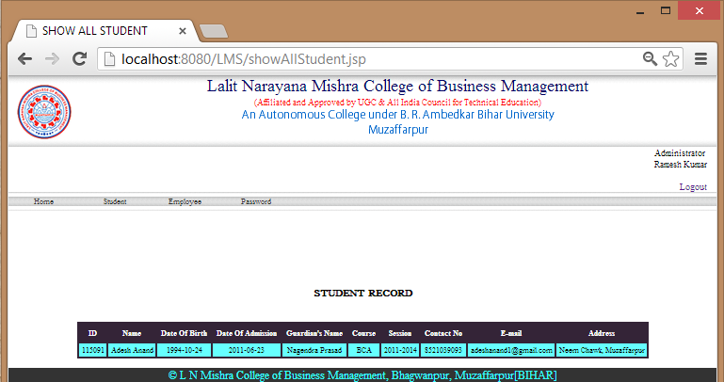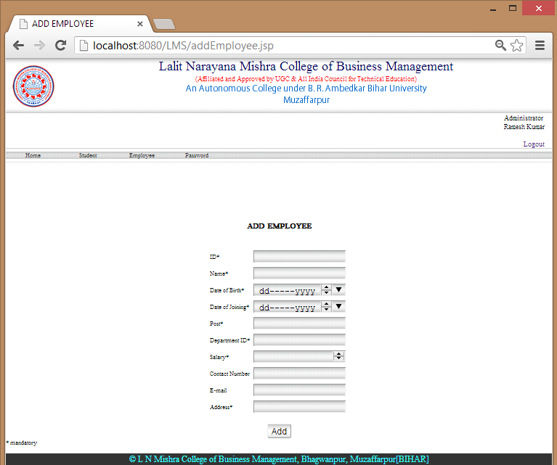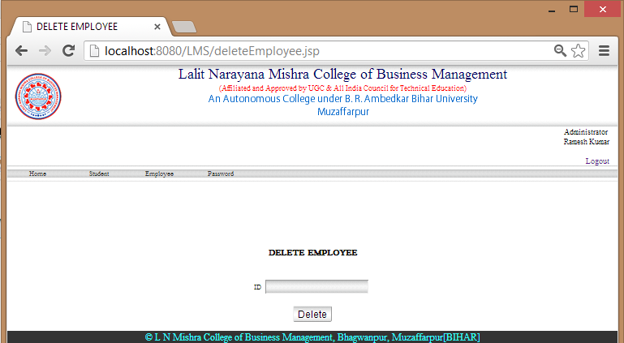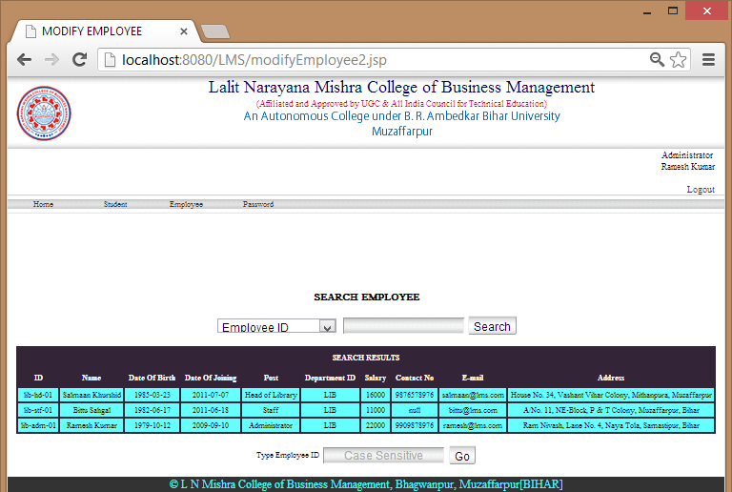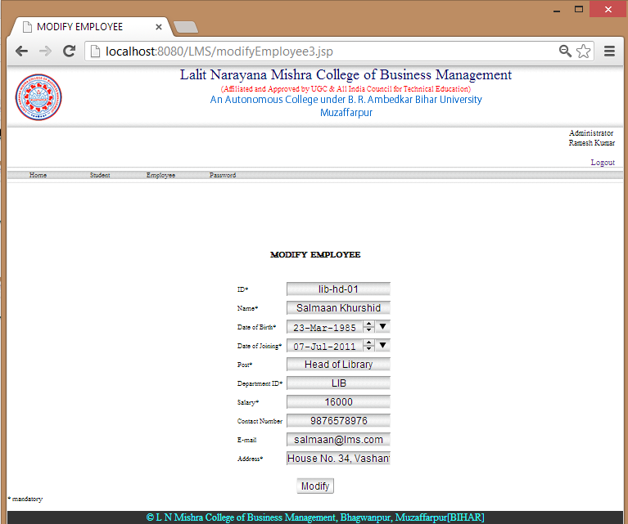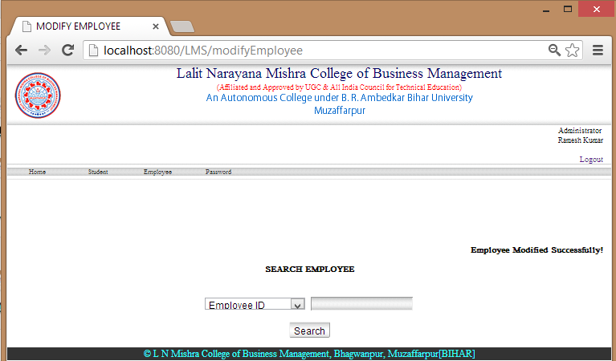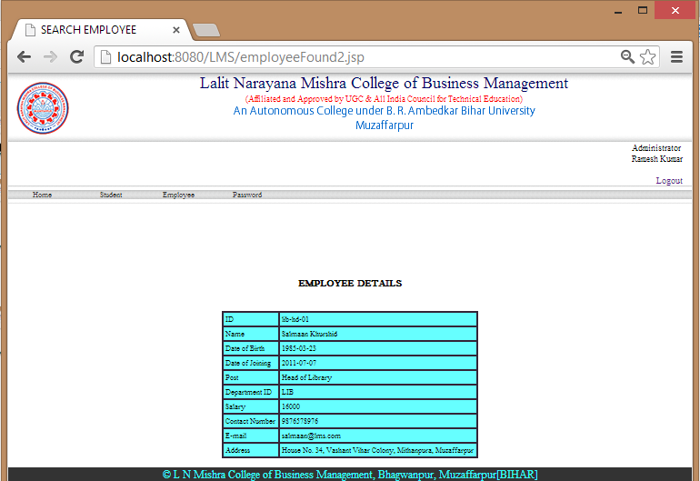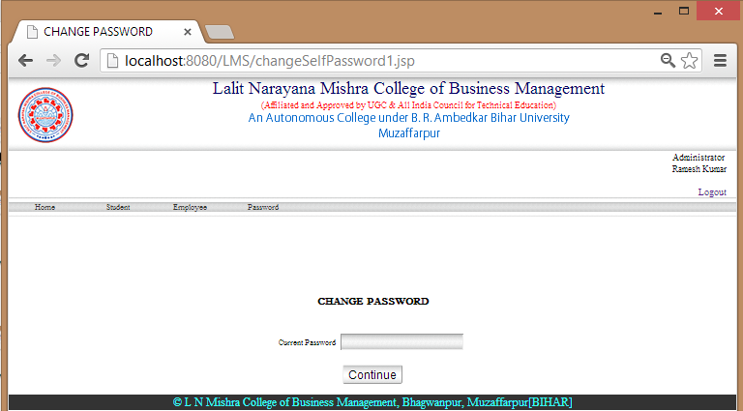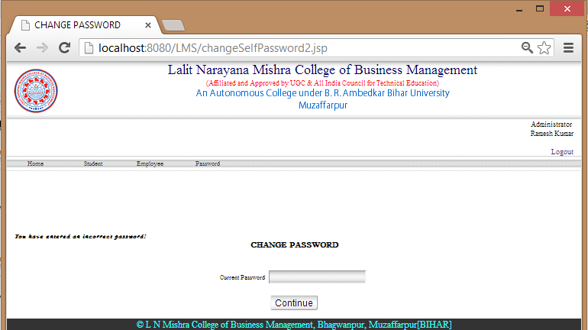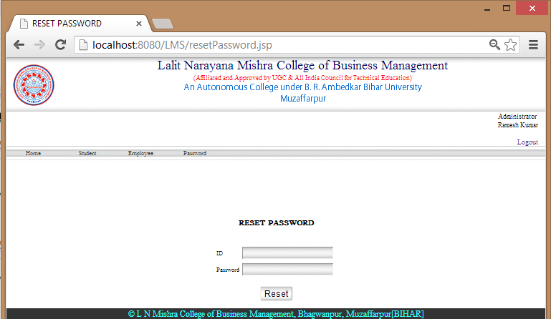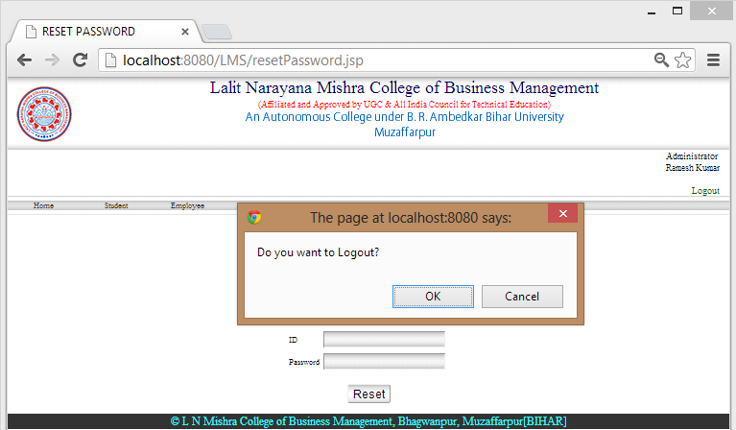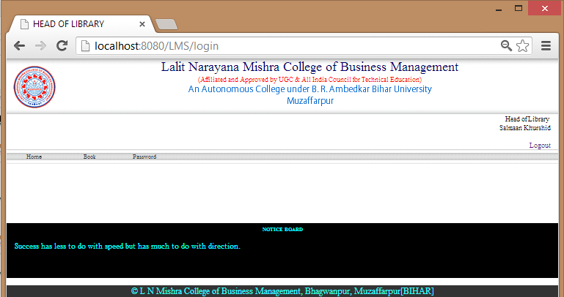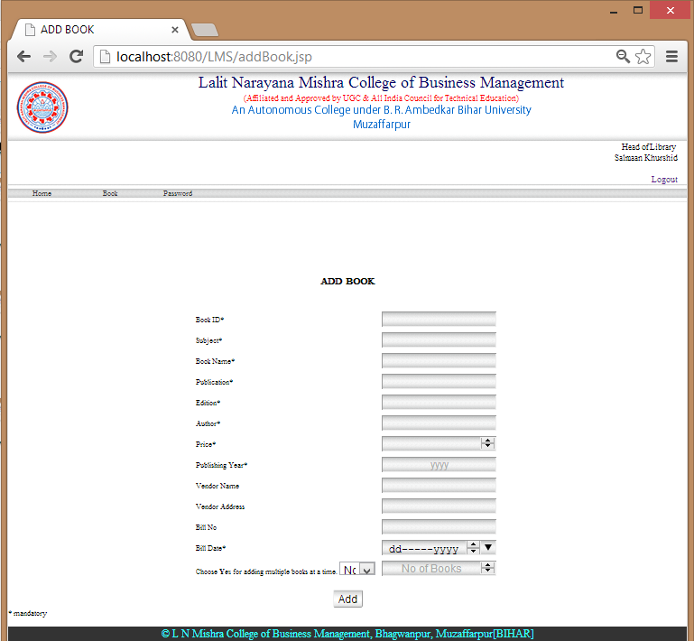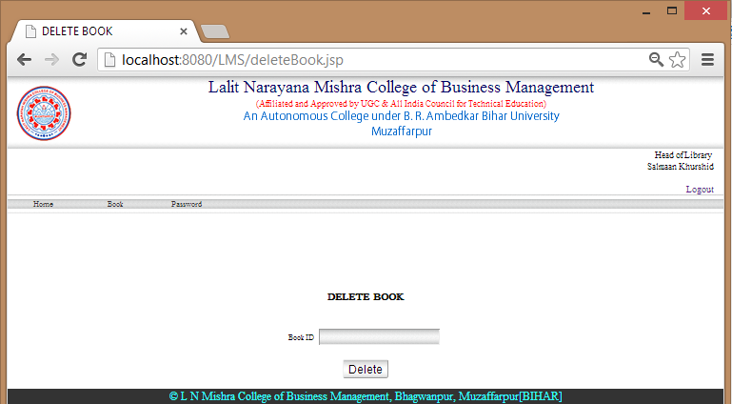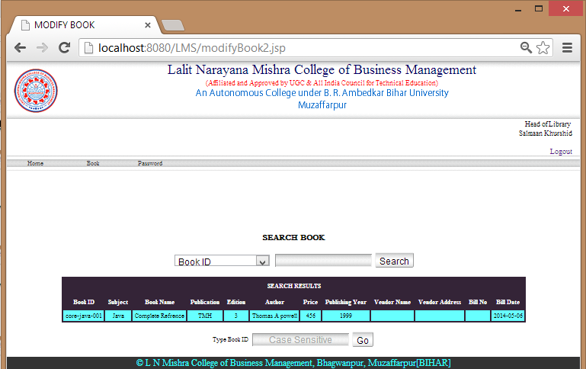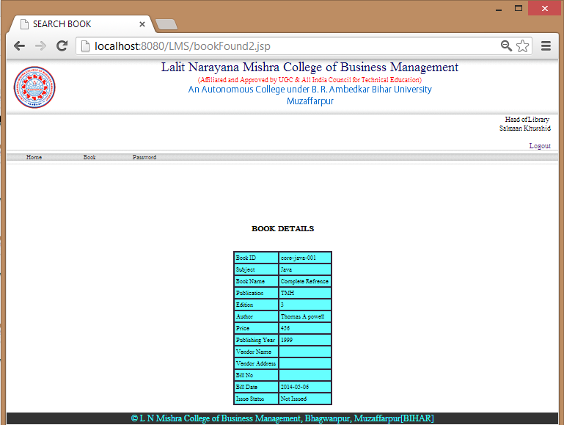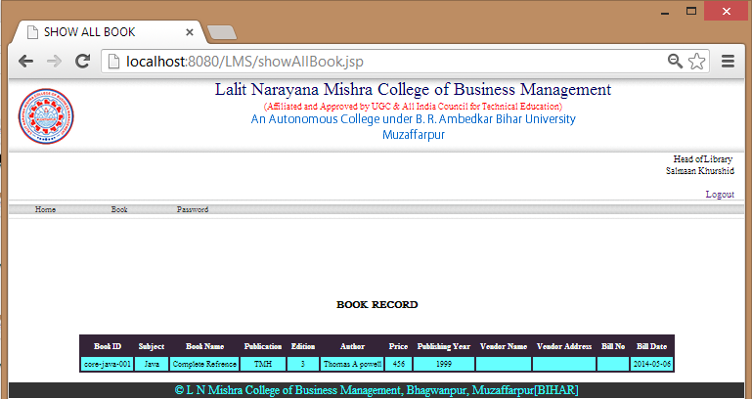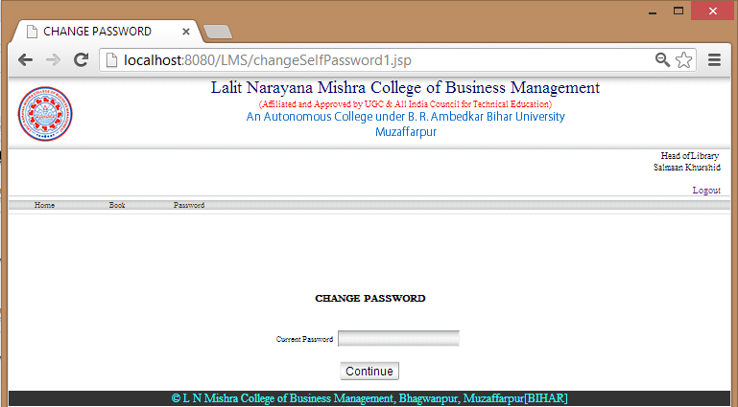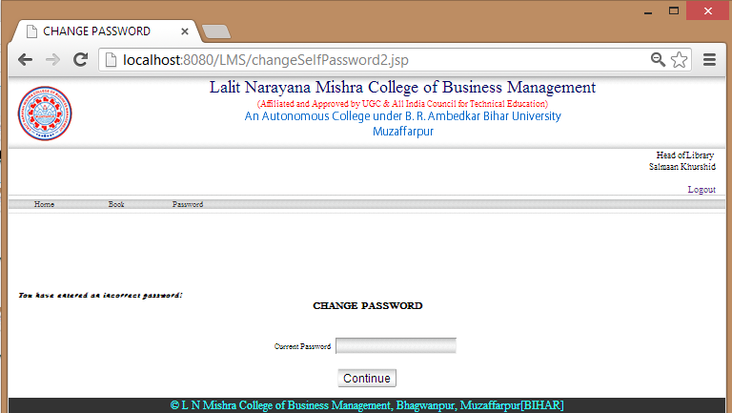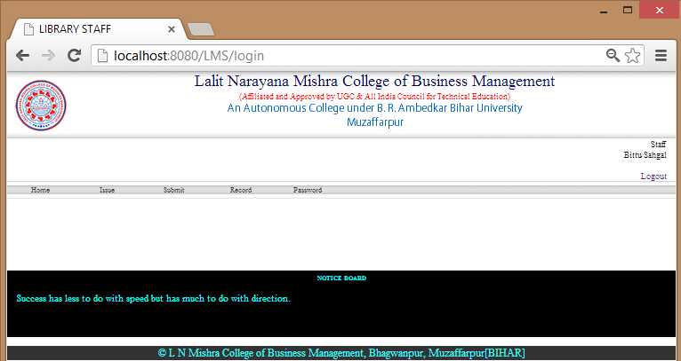
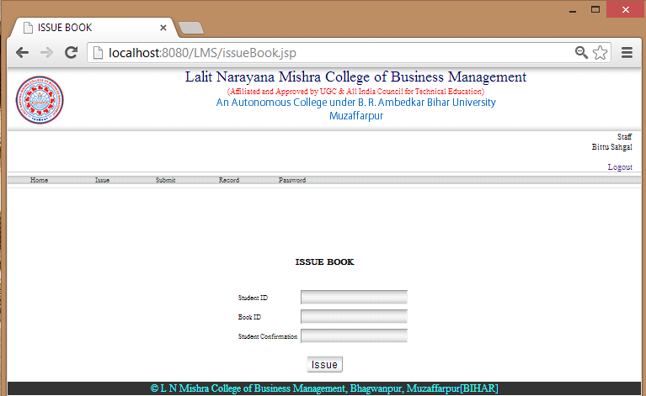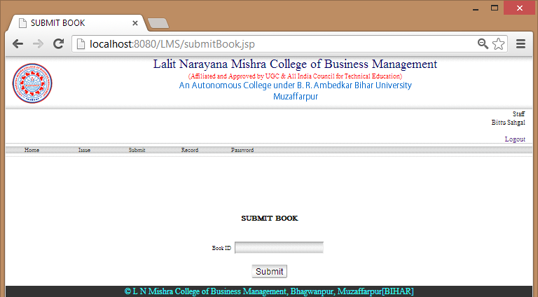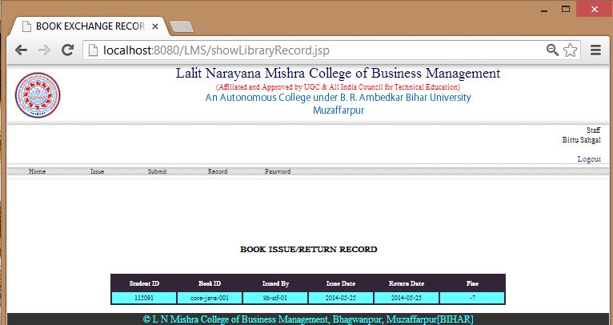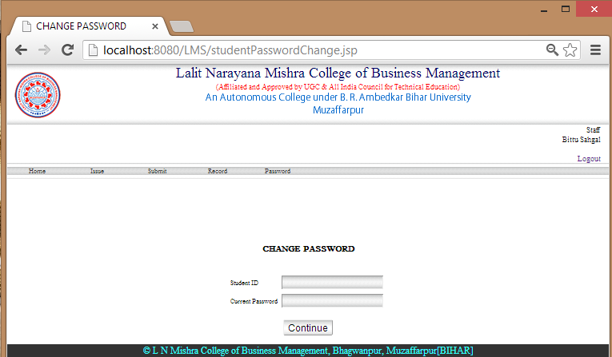

PROJECT TEAM

The Members of Online Library Management System Project Team are mentioned below:

1.) Adesh Anand
2.) Md. Shadmaan
3.) Md. Mobashshir Adil
4.) Vikrant Kumar Ranjan

REMARKS
Er. Arindam Saha



